**Link :**

[**https://v4e038.vfe.sas.com/links/resources/report?uri=%2Freports%2Freports%2Ff1850116-3a83-497a-9e60-5236f0218d24&page=vi6**](https://v4e038.vfe.sas.com/links/resources/report?uri=%2Freports%2Freports%2Ff1850116-3a83-497a-9e60-5236f0218d24&page=vi6)

1. **Data Exploration**

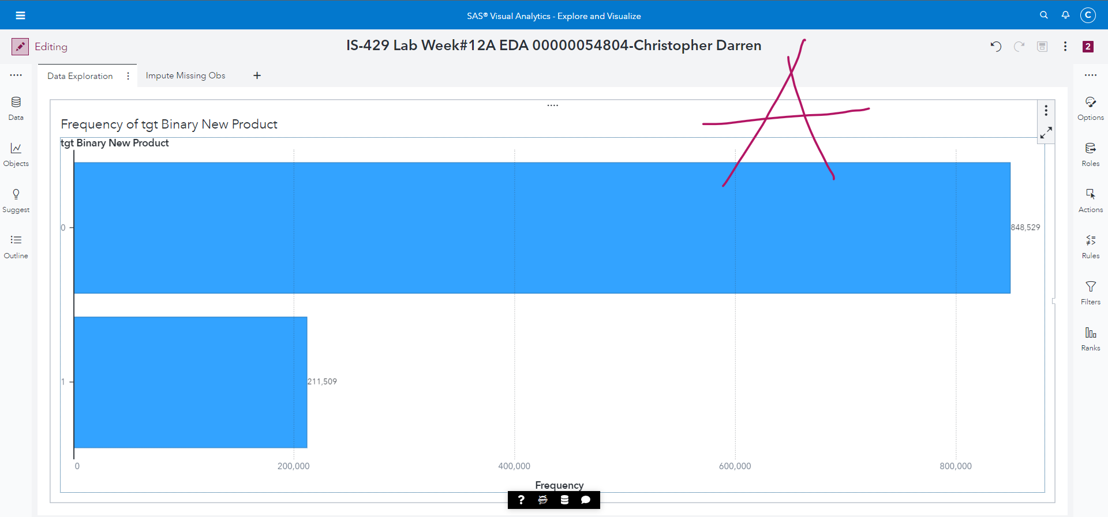

1. **Input Missing Observations**

